Problem description: In Machine Learning deployments, the data fed into the model must be cleaned. In this case, it was required to sort various images of an alphabet into 4 folders based on quality of the image, namely, Good, Bad, Edited and Mismatch. Manual segregation involving opening and sorting is error-prone and time consuming. Instead, this process can be automated so as to simplify the process using Python and its packages.
Solution: The cv2 module of Python is used to read images from the source folders and display to the user. They are then prompted to enter a single character denoting the folder into which the image must be classified. Upon receiving this character, the program then moves the image into its respective folder and moves on to the next image. This is repeated until all images in the folder have been classified.
Prerequisites: Python v3.8.5 (with packages cv2, glob and shutil installed), Python Shell(default with Python installation)
Code: The Python code can be found at this GitHub link.
Program description: The user is prompted to enter paths of the required folders in the program, following which images from the folder are read and displayed to the user using the cv2 module. Input for each image determines its destination folder. ’g’ goes into good images, ’b’ for bad, ’m’ for mismatched, ’e’ to edit. The shutil module is used to move the images from one folder to another.
Folder Structure: Create a parent folder containing:
    - Alphabet0xx…,Alphabet0yy(Containing source images)
    - GoodImages
    - BadImages
    - EditedImages
    - MismatchImages
Last 4 folders must have separate empty folders (at start of classification) for each Alphabet folder nested within.

Note: In case of accidental termination of program, the classification starts from where the execution was broken to ensure no loss of data. Also, if no valid input is given (g/b/e/m), the image continues to remain in the source folder to prevent incorrect segregation.

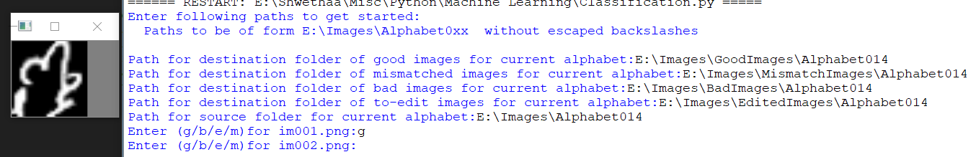

Figure 1 Sample Execution
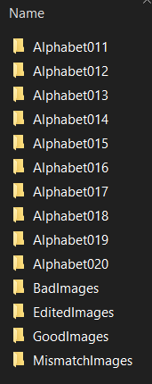
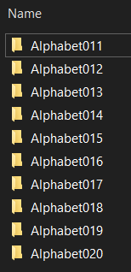
Figure 3 Folder Structure
Figure 2 Folders inside EditedImages

